Excel data sync by using Liquid Content

# Introduction

Implementing a solution by VBA in MS Excel to synchronize certain Content Types/Items by DNN REST APIs

In this tutorial, we will use Evoq Liquid Content, REST APIs to build up a solution how easily we can use MS Excel to update certain contents on the website pages in just seconds.

# Purpose of this demo

* Remove the dependency of Evoq Product and Persona Bar
* Avoid end-user to learn and understand JSon (Tree view), or complicated forms
* An easy way for end-user to maintain the data
* A tool for QA to load up data quickly

# Use Case Assumed

* HR department asked IT to create a page for job posting
* But HR didn't decide how many jobs and titles/descriptions at that moment.
* Some of the HR team members, they don't have access to Persona Bar

# Technologies Used

* Liquid Content APIs from Evoq
* Excel VBA scripting
* JsonConverter module (3rd party)
* Dictionary.cls (3rd party)

# Prerequisites

* Target website and obtain API Key for Liquid Content
  + This API Key shall have permission to read and write Content Types and Content Items
* Enable Excel micro with file extension “.xlsm”
* Load JsonConverter.bas and Dictionary.cls in Excel micro

# **Step 1: Authentication**

There are multiple methods to get REST API authentication from a client side, but here I will only introduce one of them: APIKey authentication.

# How to get DNN APIKey

1. Log in as Host User
2. Go to Persona Bar > Content > Content Library > API Keys
3. Create a new one or copy from existing ones.
4. Make sure the APIKey has proper permission assigned.

More details: <http://www.dnnsoftware.com/docs/content-managers/structured-content/create-api-key.html>

Simple Example where the APIKey is used in API calls.

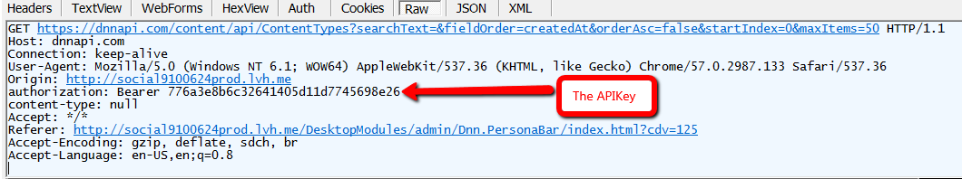

# **Step 2: API Calls examples in Excel**

# Basic GET Request

 As you can see, we can GET “Content Types” and “Content Items” by the API calls.

# Basic POST Request

 The POST APIs allow us to CREATE “Content Types” and “Content Items”; while PUT calls to UPDATE; DELETE calls to remove.

# Basic JSon POST String

JSON format is widely accepted and used in the context of NoSQL DB and serialization for information across internet. More knowledge about JSON, please refer to: <https://www.tutorialspoint.com/json/>

# JSON Strings

There are lots of open-source JSON Converter Tools on the internet. In today’s demo, I am going to use VB-JSON module to handle JSON strings. Please make sure JsonConverter.bas and Dictionary.cls are imported to Excel VBA module.

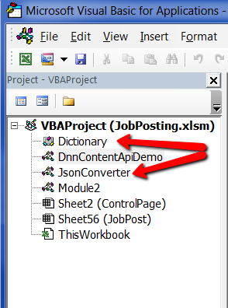

# Step 3: Put the code together to be executable in Excel for your uses.

Here I am using “JobPosting.xlsm” as today’s demo to use those modules and Evoq Liquid Content APIs to synchronize the data between MS Excel and one of the web pages.

After launching the “JobPosting.xlsm”, in sheet “ControlPage”, input “API Key” from Step 1, follow the steps as show in the screen-copy below to load all content items.

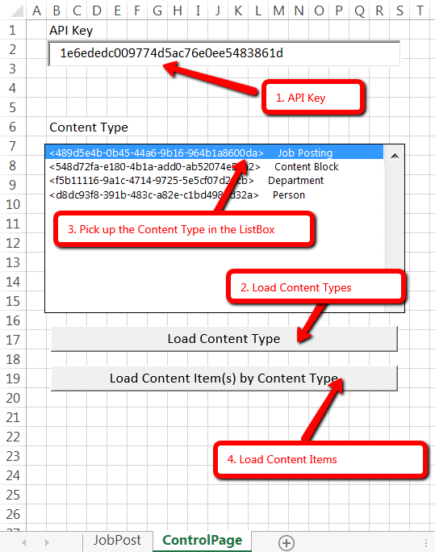

After step 4, it will automatically generate a new sheet with couple controls dynamically generated on it.

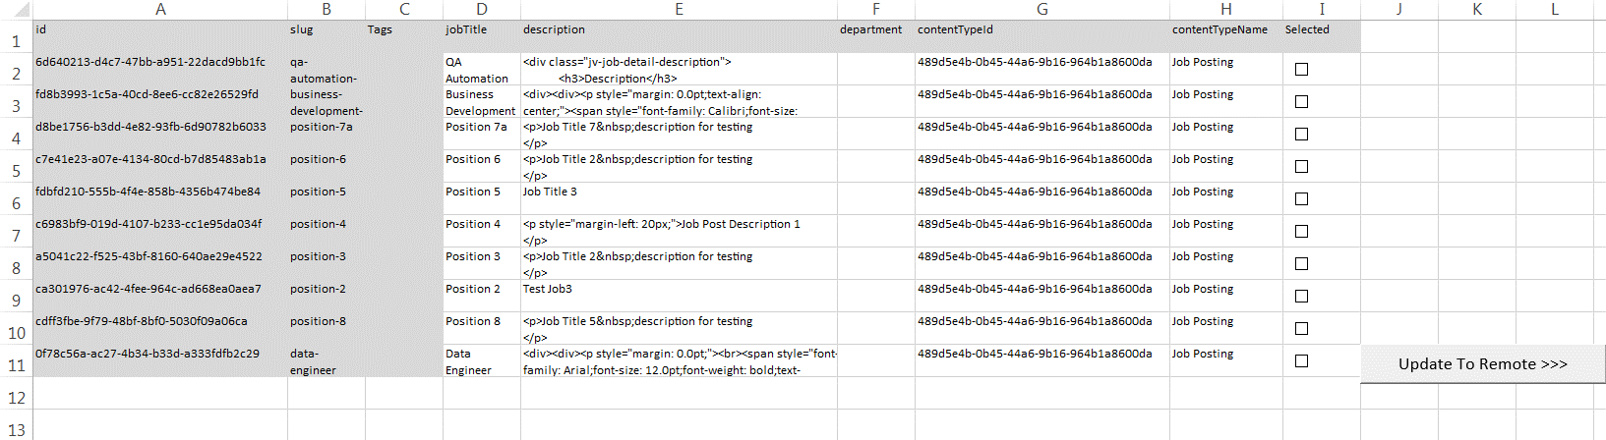

For this example, we will try

1. To add a new Job in Career

Simply fill in the data in field <jobTitle> and <description>, using the same <contentTypeId>, click the button “Update to Remote >>>”



1. To modify a Job in Career

Change the data in <jobTitle> and <description>, Check on the <Selected>, click the button “Update to Remote >>>”



# Conclusion

All data will be reflected on the web page almost immediately, and viewable by all users. No need to wait for a web developer or IT to fix the page for you, all the changes could be complete in couple seconds. Even more, considering by using the Evoq Liquid Content and its APIs, those changes could be published to multiple channels automatically at the same time.



If you have more questions, please visit our website @ [www.dnnsoftware.com](http://www.dnnsoftware.com) or call 1.650.288.3150